**Assignment AO4 - End User Needs**

**Homeless Shelter**

**Group: L**

**Introduction:**

If we solve the issue of homeless people not having access to shelters, with our solution to create a user friendly and accessible shelter that can be used by campers and homeless people, then we will be able reduce the amount of prejudice that homeless people face. In addition to the solution of the shelter we will also be following a one-for-one business model.

**Task**:

Homeless citizens living in the inclimate weather.

**Problem definition:**

Seeking an affordable and efficient shelter that can withstand different weather conditions.

**Pains**:

1. Shelter is not typically portable and is difficult to move from location to location
2. Homeless people do not have enough income to afford permanent and effective shelter
3. Homeless people often have to settle for sleeping under bridges or in areas that are not very safe without any shelter to protect them
4. Homeless people are more prone to getting sick from exposure to the elements

**Gains**:

1. Homeless people gain more of a sense of privacy and personal space
2. Homeless people have the warmth they need to protect them from the cold
3. The ability to have a portable shelter and extra storage to protect their belongings from the general public

**Assessing User Experience of Homeless People in Finding/Using Shelter:**

| -- | - | 0 | + | ++ |  |
| --- | --- | --- | --- | --- | --- |
| X |  |  |  |  | Privacy |
|  | X |  |  |  | Storage of personal belongings |
| X |  |  |  |  | Comfort |
|  | X |  |  |  | Access to food |
|  | X |  |  |  | Ease of transportation |
|  | X |  |  |  | Ability to access shelter |
| X |  |  |  |  | Protection from sickness |
|  | X |  |  |  | Sense of community |
| X |  |  |  |  | Safety |
|  | X |  |  |  | Access to medical resources |
|  |  |  |  | X | Using a portable shelter |

The chart above assesses the pains and gains that are associated with being homeless. This will allow us to understand how to better produce a quality product, to continue to maintain the gains and try to fix the pains.

**Persona:**

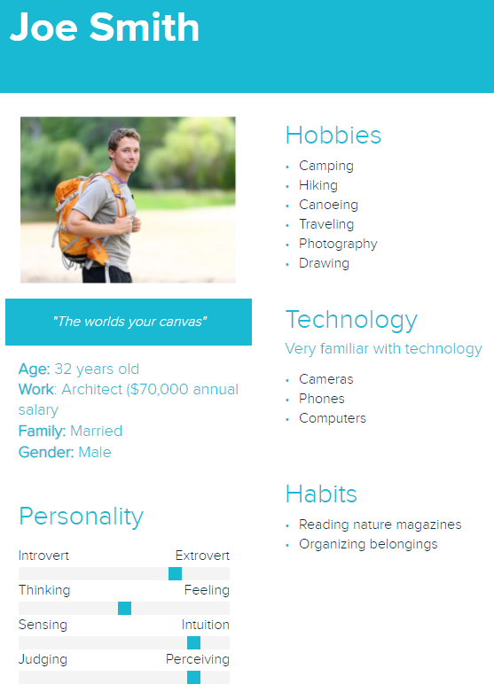

**User needs:**

*1=least needed, 5=most needed

| User Need | Score (1-5) |
| --- | --- |
| Simple | 4 |
| Cheap | 3 |
| Portable | 5 |
| Long-term reusability | 5 |
| Comfortable | 3 |
| Convenient | 5 |
| Visually appealing | 3 |

Simple- The product needs to be simple enough to expand and compress quickly with ease and cannot be so complicated that it is difficult to understand and set up.

Cheap- Since we are planning on donating one shelter to a homeless person for every purchase, the product needs to be cheap enough to produce and sell while allowing for profit even with donating the shelters for free.

Portable- The product needs to compress enough to be portable and easy to carry around for people on the move.

Long-term reusability- The product needs to be of high enough quality to be reused and last long enough to shelter homeless people and campers for countless uses.

Comfortable- Though the product needs to compress and be portable, when expanded, the shelter provided needs to be comfortable to sleep and live in. In addition, the product must provide protection from the elements.

Convenient- The product needs to be easy to carry from place to place as well as set up and take down and must be able to be set up with any environment/location.

Visually Appealing- The product must be visually appealing enough to create a clean and beautiful city. While the product is first and foremost meant for shelter, it should also have an aesthetic element to it that beautifies cities and nature settings alike.

**Pairwise Comparison Chart:** The pairwise comparison chart helps us rank which features of our product we deem to be the most important; the higher the total, the higher priority that aspect of our product is. For instance, we have decided that long-term reusability is the trait we value most in our product.

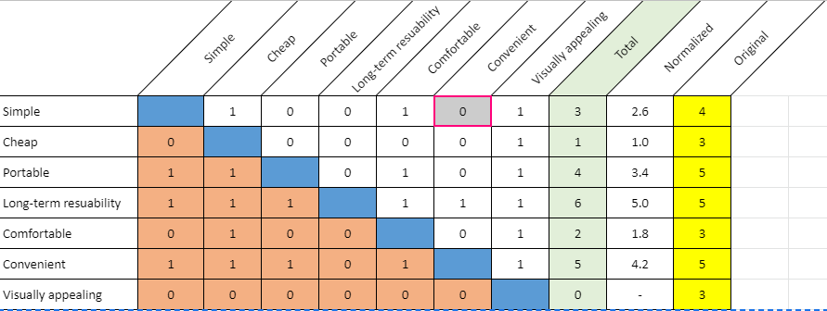

**Appendix:**

| **AO4 Assignment** | | | |
| --- | --- | --- | --- |
| **Project Manager for Assignment** | | | |
| Avi Popat | | | |
| **Deputy Manager for Assignment** | | | |
| Leah Norton | | | |
| **Drafted Assignment** | **Reviewed Assignment** | **Revised Assignment** | **Proofread Assignment** |
| Ella Wulforst | Leah Norton | Ashwin Rajkumar | Avi Popat |
| **Created Figures** | | **Created Tables** | |
| Ashwin Rajkumar | | Ella Wulforst | |
| **Other Contributions** | | | |
| N/A | | | |
| **Problems Overcomes** | | | |
| N/A | | | |